

**Business Class**

**atUpto**

**50%Discount**

**GET THE BEST DEAL *NOW***

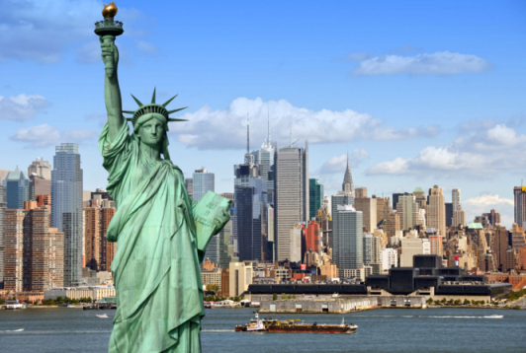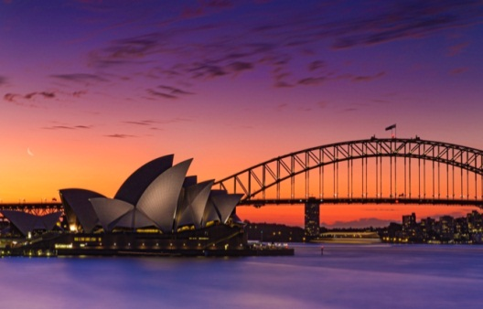 ***Call: 020 3727 6363***

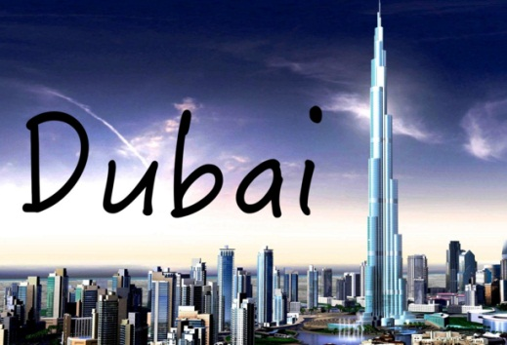

**We have special deals with all the major airlines and have fares for over 450 in the world. Our deals are often cheaper than going direct to the airline. Contact us now to get the best deal for 100s destinations around the world. Talk to our experts and book your flights and holiday with full ATOL protection.**

***Best deals***

***Business Economy***

***Auckland from £2070 from £645***

***Australia from £1700 from £555***

***Bangkok from £1400 from £340***

***Dubai from£1280 from £290***

***Hong Kong from £1490 from £329***

***Johannesburg from £1790 from £436***

***Los Angeles from £2200 from £479***

***New York from £1450 from £379***

***Fares are subject availability***

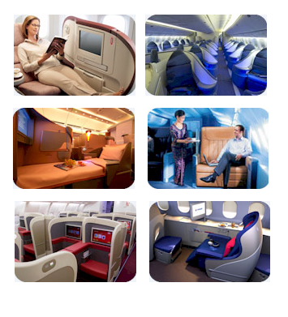

***What you get in Business Class:***

* *Comfortable Flat Bed seats*
* *On board privacy*
* *Special on board menu*
* *Relax and dine in Business Lounges*
* *Priority Boarding*
* *Exclusive on board bar*

*PS. Services may vary by airline and aircraft*

All our flights and holidays are ATOL(no. 10713) protected. This email has been sent to you as a previous traveller. If you do not wish to receive future emails, please send a reply email. Super Destinations Ltd is a company (8243733) registered in England and Wales, Registered Office: Sir Robert Peel House, 344-348 High Road, Ilford, Essex. . (VAT No. 1862051 12)